**University College Dublin**

**School of Computer Science & Informatics**

Introduction to Project Management COMP20140

Learning Journal

Paul McDonagh 13325876

Group: 3 – Second Chance

Date of Submission:

23rd of April 2015

Lecturers:

Dr. Joe Carthy

Dr. Meadhbh O’Connor

# Module Goals

I start this module with high expectations of myself and this module. I have a keen interest in project management and possibly intend to pursue a career in this area. The simplest way I can set out my goals for this module is in bullet points, clear and concise as goals should be.

* Improve management skills/ learn skills.
* Learn leadership skills.
* Improve organization and learn techniques to do this.
* Improve my life by being able to organize it in a way to have more time to do things I like to do.
* Improve my group skills.
* Achieve an A+ grade.
* Use skills, time management skills in everyday life, use to help achieve goals in life and goals in other modules.
* Achieved with smart work, organizing time in order to make the most out of my precious time and maintain and improve my high grades.
* Make time for the people and things that are important to me
* Learn to priorities.
* Collaborate with students from different disciplines in order to gain the most out of everyone’s talents.

# Week One Review

1. **Write your Goal Entry for this module – see Assessment Details on Moodle for explanations of this entry.**

Check!

1. **What are the other entries for your Learning Journal?**

One for each week with each week being sub divided into smaller sections possibly two sections, one for each class. There will also be three special entries; Goals, Book Comparison and Module Review Entry.

1. **How should the Learning Journal be structured?**

Name and student number must be printed on the cover. The first page of your journal should be Special Entry 1 (Goal entry). Questions posed each week should be printed with the answer clearly identified below it with spacing between each question and answer. Special entry 3 (Review entry) should be on the last page of your journal. These entries should be saved in a Word document a printed version of which must be submitted in week 12.

1. **How are the marks for this course allocated? What are the compulsory elements?**

End of Semester Exam – 40%

Practical Work - 60%

* Book Review – 10%
* Learning Journal – 20%
* Group Project – 30%
  + Microsoft Project Test (Must PASS)
  + Project Report (5%)
  + PowerPoint presentation (Must Pass) and 4 minute video (10%)
  + Confidential Report (15%)

Lectures are compulsory and no grade will be given to the group work section of the marks if more than two lectures are missed without a genuine excuse.

1. **Your time and your important “things” In the lecture we carried out a “time alignment” exercise where we wrote down the 5 things that we spend most time on and the 5 things that are most important to us. Do this as a personal exercise. You do not have to record your 10 things in the journal.**

Check!

1. **Write a short reflection on what you have learned from this exercise.  
   For more information see Moodle document: “The Time Management Secret to Eliminate Your Time Wasters” or the url:**

[**http://www.asianefficiency.com/goals/the-time-management-secret-that-will-eliminate-all-your-time-wasters/**](http://www.asianefficiency.com/goals/the-time-management-secret-that-will-eliminate-all-your-time-wasters/)

From our time management exercise I learned that I am filling my time with unimportant things such as watching television and playing the xbox. As I am studying engineering lectures take up a lot of my weekly time, therefore I should be managing my time off more efficiently and making more of myself in this time.

1. **In Lecture 2 I presented an Excel weekly timesheet. Download this sheet and complete it for your tasks. Feel free to add/delete/edit the rows. Print and paste this sheet into your journal.**
   1. **What do you notice about where you spend your time**
   2. **Does this surprise you?**
   3. **Are there obvious changes you might consider making?**

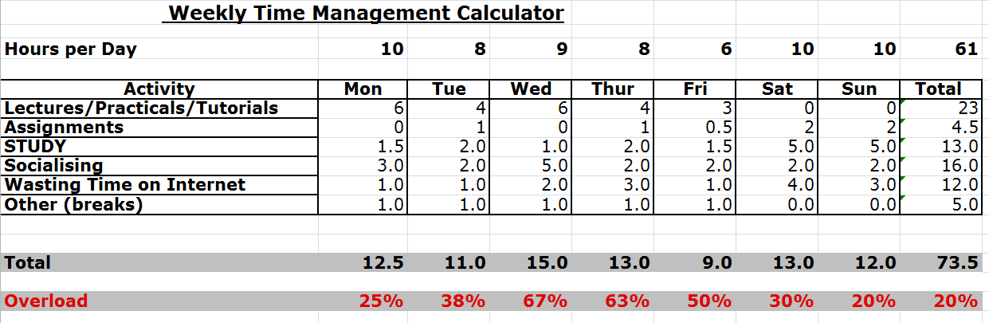

**A)** This exercise helped clearly show where I spend my time. Clearly looking at my overload, I am spread too thin trying to do more than I can, leading to certain aspects and items being rushed and the proper care not taken when completing tasks. For instance this week’s journal entry was pushed to week two as I didn’t plan properly and ended up running out of time last week. This shows a clear need for prioritisation within my daily life.

**B)** This doesn’t surprise me and I assume it wouldn’t surprise most people that they are over worked and as most Irish mothers say on a daily basis “there isn’t enough hours in the day”. How true this saying is.

**C)** Initially there aren’t any obvious areas which I can cut down on time spent. In life everything must be balanced and looking at my time management, I am not balancing it correctly. I need to reduce time wasted on the internet and in general time wasted with procrastination and lack of motivation at times. I try always to get the most out of life and college and re-evaluating where I spend my time is a necessary thing to do.

**7 Download and install Evernote on your PC or smartphone or tablet**

* 1. **Create a list and store it in Evernote**
  2. **Print and paste this list into your journal**
  3. **Why is a cloud-based system useful?**

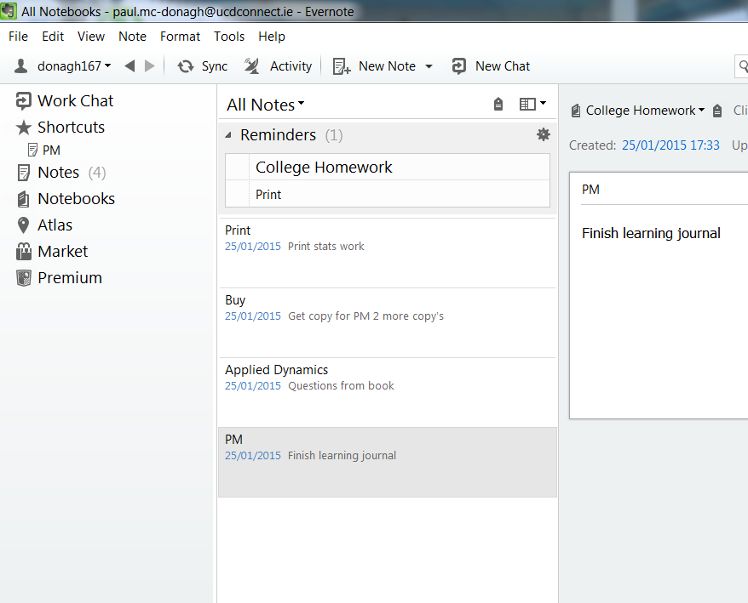A cloud-based system, such as EverNote, is very useful as it allows notes saved on a desktop, laptop, tablet and smart phone all to be linked and synced with each other meaning you are always on top of your to do list.

**8 When dealing with lists, what is a context and why is it useful to note the context for a task**

adding locations to your to do lists, so you can arrange your list by what you have to do depending on where you are, so you've a list for work, a list for home, a list for personal stuff, etc.

**9 Which computer-based list system do you think might be useful for you?**

I have downloaded a number of different apps to my mobile and also Evernote to my laptop;

-Tomorrow

-Any.Do

-Evernote

I decided not to decide on just one computer based list system for my first two weeks until I have time to evaluate each one and decide which one appeals to me and my style of remembering most. I like that Evernote has a desktop application along with the mobile app which synchronise with each other. Any.to has a similar feature however it doesn’t require you download a program to your computer and instead it can be accessed from any computer with internet access. Tomorrow doesn’t have a laptop based program however it’s simple and heat design is very appealing and my phone is always by my side anyways.

**10 Explain the idea of filing your “stuff” using the 43-folders methodology.**

The 43-folders methodology is simple in design and beautifully simple. Imagine a filing cabinet and in it 12 folders, one for each month of the year. Then within the given month that it is, you have 31 sub folders one for each day, totalling 43 folders. Tasks and “stuff” can simply be filled into the day which they are needed for and once there can be forgotten about as you know when it comes to the 12th of march and you are looking for your boarding pass, it will be in the folder for the 12th of march. Using this system allows you to organise everything so that

**Week 2**

1. **What is does Covey mean by the P/PC balance? Can you give a personal example of it?**

There is a need to balance Production (P) and Production Capability (PC). For example, if I chose to get up every morning at 6am to go for a run and study before for college and also stay up until 2 am to give me more time to socialise with my friends. Short term this would be great, I would enjoy myself every night and become fit during the morning. However very quickly my body would collapse and I would end up getting sick from exhaustion and end up becoming less productive than if I choose to sleep for 8 hours every night.

1. **Explain Covey’s first habit.**

Covey’s first habit is; Be Proactive. By this covey means that in the business world you need to take initiative to get work done yourself and without constant checking and questioning the task at hand. Try and foresee problems and take it upon yourself to find a solution and act upon it.

1. **Covey argues that others cannot make us angry – we are responsible for our own response. Do you agree with this view?**

No, and I will use the scenario of “fight or flight” to basis my theory. When faced with this situation most will flee but some will stay and fight. What controls this most basic human instinct? This decision is made without thinking in a split second, and so I would argue that it is ones upbringing and state of mind that decides their response.

I think that a person’s initial response to any situation is instinct, however one can choose to assess the situation and decide to change their state of mind from the initial response, and then act with this new state of mind.

1. **Explain the idea of the circle of concern and the circle of influence. What is your opinion of this idea?**

The idea of a circle of concern and circle of influence states that there are issues around is that we can categorise into thins that we can influence and deal with directly and things which are outside of our control, but are still our concern.

I don’t agree that there is a clear cut and defined lines. I believe that the circle of influence and concern become intertwined as one decides to increase the effort they are willing to put into it. If someone feels strong enough about an issue there is **always** something that they can do to help. The border lines to this circle increase as we decide to give up more of our time and devote ourselves to this issue.

A lot of charities and trust funds are sparked by a person’s personal experience, if someone they love dies from cancer, they might then decide to move this issue from their circle of concern to their circle of influence by setting up a charity to help people affected with cancer. Does this ability to move things from your circle of concern to your circle of influence not undermine the theory that these lines exist?

1. **Why is habit 1 relevant to a project manager?**

Being a project manager requires the ability to make decisions without constantly consulting and fundamentally annoying your boss with small issues that they doesn’t need to be concerned with. As a project manager you have responsibility for a project and therefor you must take control and know when it is appropriate to consult with your boss and when you can make the decision. This requires the ability to be proactive in your decision making.

1. **How does O’Connell define a project?**

O’Connell defines a project as work done by an organisation on a one time basis to produce a unique outcome.

1. **According to O’Connell, what is structured PM?**

Structured project management is an approach to project management that uses a 10 step check list to focus on the goal and keep on target.

The ten steps are;

1. Visualise the goal
2. Make a list of the jobs to be done
3. There must be one leader
4. Assign people to jobs
5. Manage expectations, allow error margin and fallback
6. Use an appropriate leadership style
7. Know what’s going on
8. Tell people what’s going on
9. Repeat Steps 1-8 until step 10 and finally
10. The prize
11. **What is the First Law of Project Management**

O’Connell’s first law of project management is a function:

Function(Functionality, Delivery date, Effort, Quality) = C

If you change any of the variables then the others will change accordingly.

1. **What does O’Connell mean by PSI?**

Each step of a project has a knock-on effect with the following steps. PSI means the effect each step has on the probability of success of the entire project. PSI is weighted differently for each step and project.

1. **What is Step One in O’Connell’s 10 steps?**

Visualise the goal; Set your eyes on the prize.

**Week 3**

1. **Why is visualising the goal so important in O’Connell’s view ?**

Visualising is a vital part of project management. O’Connell believes that it clarifies the project, giving you the reasons for doing the project. It also gives you a glimpse of success with the project and reduces the risk of scope creep.

1. **What does O’Connell mean by PSI?**

Each step of a project has a knock-on effect with the following steps. PSI means the effect each step has on the probability of success of the entire project. PSI is weighted differently for each step and project.

1. **Why is Covey’s Habit 2 important in project management**

Covey’s second habit is the keep the end in mind. This habit is about leadership, being able to make decisions with the end goal in mind and without constant checking and reassurance. This is a vital skill for any project manager.

1. **What are SMART goals**

SMART is an acronym for Specific, Measurable, Agreed upon, Realistic and Time-based. These 5 steps are vital when planning a project and answering these questions prior to starting any project is a great way to keep on track and focused on the end goal of the project.

1. **What is O’Connell’s visualisation checklist**

O’Connell’s visualisation checklist is very simple and consists of three parts; Functionality, Time/scope, Good/bad

1. **What is meant by structured project management**

Similarly to the question from the previous week, structured project management is an approach to project management that uses a 10 step check list to focus on the goal and keep on target.

The ten steps are;

1. Visualise the goal
2. Make a list of the jobs to be done
3. There must be one leader
4. Assign people to jobs
5. Manage expectations, allow error margin and fallback
6. Use an appropriate leadership style
7. Know what’s going on
8. Tell people what’s going on
9. Repeat Steps 1-8 until step 10 and finally
10. The prize
11. **What is a RASIC matrix and why is it important**

RASIC (RACI) Matrix – Responsible – Approve Accountable – Support – Informed – Consulted

It is an important checklist as it allows traceability for all tasks. Clearly defined roles responsibilities with all parties knowing the expected final outcome and who is responsible for achieving this.

1. **What is a Role Responsibility Chart ?**

The role of a responsibility chart is to clearly define and layout roles and responsibilities for everyone within the team. This chart allows for traceability if an issue arises where a task was not completed or not done to a high enough standard.

1. **What is a Milestone Schedule Summary**

A milestone schedule summary is a menthod which focuses on the small goals and small wins, breaking down a large project into smaller component. We then set milestones or small goals to have completed by a certain date. For instance in building a house some milestones might be to have the site cleared by week2, foundations dug by week4 and begin block-laying by week 8. These tasks need to be further broken down, but when we come to a milestone it’s a great confidence boost motivating the whole team.

**Week 4**

1. **From Step 2, what is a SWAG and why is it an important idea?**

SWAG is an Acronym which stands for: Sophisticated Wild-Ass Guess. It is important as project managers are constantly asked about deadlines and due dates. Using this method to make educated guesses based on the information available to the PM is invaluable.

1. **In the context of Step 3 from the text, write a note on the Scott and Amundsen case studies**

Step 3, discusses the importance of having one well-organised leader. However having one leader does not guarantee success. For example, Roald Amundsen and Robert Scott, were both leaders on expeditions down to the south pole. In fact they were racing each to get there. However, as it transpired Amundsen was a good leader, whereas Scott was not. Amundsen, had the whole trek organised to a tee. Food was rationed perfectly; transport was sorted, unlike scott who travelled on foot. As it transpired, Amundsen succeeded and Scott did not.

1. **What is Covey’s 3rd Habit ?**

Coveys 3rd habit is; Put first things first. This habit is about time delegation. There is a finite number of hours in the day/week and we need to ensure we complete the important things in our lives, such as having time for family and friends.

1. **Give 2 important points on the slides presented in** [***Brian Prays’s youtube video Jar Of Life - Put IMPORTANT Things FIRST***](https://www.youtube.com/watch?v=6_N_uvq41Pg)

Pray’s video relates closely to Covey’s 3rd habit and the Pareto principle, we need to organise our lives in order to make the most out of the time we have and fit all the things that are important to us in. the people and things that are most important should be prioritised. The engineer in me took from the video that space and the term “full” is relative.

1. **Explain what type of activities occur in Covey’s 4 quadrants**

Quadrant 1: Urgent and Important

-Crises

-Deadline driven projects

Quadrant 2: Important but not Urgent

-Recreation

-Planning

Quadrant 3: Urgent and not Important

-Calls

-Some meetings

Quadrant 4: Not Important and not Urgent

-Time wasters

-Social Media

1. **Give 2 or more examples from you own life of activities for each of the 4 quadrants.**

Quadrant 1: -College Work

-Family

Quadrant 2: -sport & exercise

-Relaxing

Quadrant 3: -Call from parents

-Emails

Quadrant 4: -Social Media

-Socialising

1. **What does Covey mean by effective delegation?**

Effective delegation relies on trusting people to make the right decision on how to do something but making sure they know and are responsible for the end result.

1. **What is opportunity cost?**

Opportunity cost is the benefits you could have received had you chosen an alternative method.

1. **What is the Pareto principle?**

The Pareto principle is; spend time on the small number of things that affect a large amount of our lives.

**Week 5**

1. **Why must there be one leader for a project?**

O’Connell’s 3rd step state’s that there must be one leader. This is simple in theory but when it comes to group dynamics and personalities, it can be hard to have a clear chain of command. Without a clear line of command there is no accountability and clear leadership.

1. **Briefly describe the Amundsen Scott case study on leadership**

On scott’s and Amundsen’s expeditions, they were both leaders of their projects respectively. However, it comes down to good leader/bad leader. Scotts expedition was a failure as they all died, whereas Amundsen’s was successful as everyone lived. It came down to what the two leaders valued. Scott was too intent on reaching the pole first.

1. **What does Covey mean by the “abundance versus scarcity” mentalities?**

The abundance vs scarcity mentalities are different ways of looking at a situation. The abundance mentality is a more positive outlook, trying to ensure everyone is accommodated, while the scarcity mentality is selfish and believes that if someone else gets something it means we won’t. (if he gets a big slice of cake that means I will get a smaller slice.)

1. **What are the different options with win and lose**

Win-win: this is the ideal where both parties win

Win-lose:

Lose-win:

Lose-lose:

1. **Why is the “no deal” a useful option?**

A project manager should never commit to fulfilling a goal that they know they will not meet. As a project manager your reputation and past records are vital. Any tarnishes or stains can be disastrous to your future business prospects. It is better to go with the no deal option and walk away.

1. **What is a Gantt chart and why is it useful in project management?**

A Gantt chart is a series of horizontal lines shows the amount of work done or production completed in certain periods of time in relation to the amount planned for those periods. It is used by project managers to clearly lay out the work that has to be completed and create a time scale for the entire project. Gantt charts can have enormous amounts of information in them such as; who will complete each task and by using software such as MS Project a project manager can make adjustments to the chart easily.

1. **Using MS Project (or another PM tool such as Smartsheet), create a Gantt chart for the following Building Project. You should paste the chart into your Learning Journal.**

**The project starts on May 2nd 2015**

* 1. **Task 1 – Site preparation taking 1 month**
  2. **Task 2 – Complete foundations and base, taking 1 month after Task 1 completed**
  3. **Task 3 – Build walls and finish floors – taking 6 weeks after Task 2 completed**
  4. **Task 4 – Roof work – taking 5 weeks after Task 3 completed**
  5. **Task 5 – Choose kitchen and bathroom fittings – starting in week 4 for 6 weeks**
  6. **Task 6 – Choose general furniture for kitchen, bedrooms, sitting room – starting week 10 for 4 weeks**
  7. **Task 7 Plumbing – taking 3 weeks starting at same time as Task 4**
  8. **Task 8 Electrical work taking 3 weeks starting in 4th week of Task 4**
  9. **Task 9 – Install kitchen and bathroom facilities taking 3 weeks after Task 8 completed**
  10. **Task 10 – Painting and decorating, taking 3 weeks after Task 6 completed**

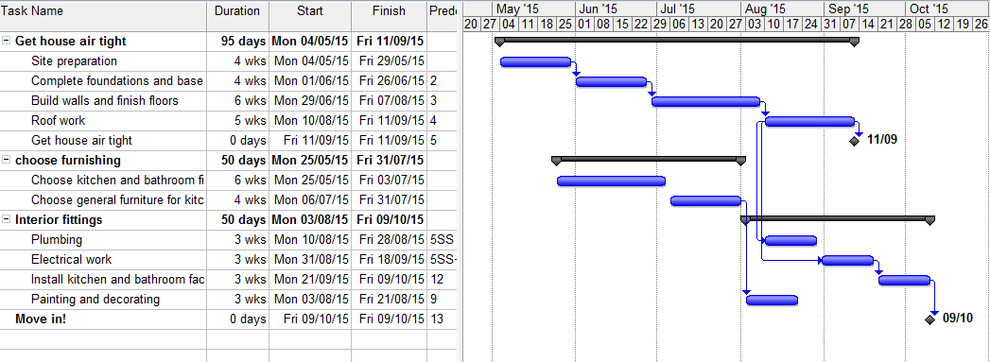

**Week 6**

1. **Write a note on Covey’s 5th habit. What does he mean by an EBA?**

Habit 5: seek first to understand, then to be understood

When starting a new project and working with people it is a good idea to start by asking questions. Find out what is currently being done, how the system/team currently work. Don’t assume anything to make sure you understand the customer and that you don’t just jump to any conclusions. Empathise with the customer, let them know you understand them and then they will lower their defences and allow you to work freely as they trust you.

EBA stands for Emotional Bank Account; here covey means that you must understand the person and their reactions. This allows you to understand why someone acts or reacts in the manner which they do.

1. **What is empathetic listening?**

Most people listen not with the intent to understand, but with the intent to respond. Empathetic listening is about really listening to the customer or whoever and trying to understand their point of view.

1. **What is a bright spot or positive deviant? How can the approach of studying positive deviants help solve project management problems?**

Positive deviance is the observation that in every community there are certain individuals who do uncommon (abnormal) things, but which in the long run, turn out to be better solutions to problems. In project management, this is almost a proof that, you should listen to everyone in the group to see their input, even the people who may not talk very much. Or in relation to solving problems, PM’s should look to the obscure to find answers to their problems.

1. **What is the key importance of O’Connell’s Step 4?**

O’Connell’s 4th step is Assign people to jobs. This has a twofold importance. Firstly it makes people accountable for their task with the end product being fully traceable. Secondly, by assigning people to jobs and not jobs to people you can maximise your team’s ability to succeed by utilising people’s skills and time available to work on this project.

1. **What is the issue of people’s commitments in Step 4?**

When assigning people to jobs it is imperative that people’s prior commitments be taken into consideration. A person should only be assigned to the task if that person has enough available working time to complete the task without risking other projects not getting the attention they need.

1. **What are the 4 villains according to the Heath brothers when it comes to making decision**
   1. Narrow Framing – only seeing a limited number of options
   2. Confirmation Bias – only gather self-serving evidence
   3. Short-term Emotion – tempts you to make the easy decision/ reciprocation of nice behaviour
   4. Overconfidence – You can be wrong about how the future will unfold
2. **Write notes on each step of the WRAP process**
   1. **Widen** your options – look elsewhere and don’t make any assumptions.
   2. **Reality** – test your assumptions and don’t go on someone’s word.
   3. **Attain** distance before deciding – take time to decide and never rush into a situation because this is the “only solution” because there was always a second and third option which should be explored.
   4. **Prepare** to be wrong – this comes back to not making any assumptions. It’s perfectly ok to be wrong and fail as long as you react correctly to the situation
3. **What is meant by “ooching”, “vanishing options”, “setting a tripwire”**

Ooching: A method of testing a decision in order to observe the possible results of this decision.

Vanishing Options: this is an interesting technique used to help decision making. By removing the “only” option, it allows for creative problem solving.

Setting a Tripwire: this is another method of helping decision making. By setting a deadline or a condition where by a decision must be made by, it influences decision making.

**Week 7**

1. **Explain what Kahneman means by System 1 and System 2?**

System 1 & 2 are both reaction instincts to decision making. System 1, is a fast emotion and instinct driven decision method. System 2 is a more thought out and logical method requiring more effort.

1. **Explain some of the biases that arise according to Kahneman such as: anchoring, loss aversion, sunk cost, framing and availability.**

**Anchoring:** this bias concerns how we are influenced by irrelevant numbers. An example of this is Gan dhi’s age experiment.

**Loss Aversion**: People fear losing something even if it is of little value, simply as it was once ours we feel attached. Companies capitalise on this with their advertising.

**Sunk Cost:** having already invested in a project, people will overlook the inevitable failure of a project and invest more as they are connected and attempt to avoid regret.

**Framing:** rewording or phrasing something in order to influence someone subconsciously spinning the fact to become a good thing. A perfect example of this from the lecture slides is the 90% survival rate compared to the 10% mortality rate.

**Availability:** People have a tendency to make judgements about repercussion or consequences based on how easy it is to think of an example of one. E.g. traveling in a car and thinking it is more dangerous as you heard of a car crash he previous week

1. **The Heath brothers refer to the elephant and the rider in their text Switch. They refer to 3 ideas that are useful in trying switching behaviour, namely “directing the rider”, “motivating the elephant” and “shaping the path”. Explain these 3 ideas and in the case of any one of them, explain how a project manager might use the idea.**

**Direct the Rider**: don’t have a definite path, aim towards a final goal and adapt to changes in the path

**Motivate the Elephant:** find a feeling and use it to motivate your team. Make people form and emotional connection with the task.

**Shape the Path:** Change the situation to change behaviour. Form good habits. The automatic natures of these new cognitive habits help the rider feel less taxed by the task at hand. Ensure this good behaviour spreads to the herd.

1. **Watch Barry Schwartz’s Ted talk on the Paradox of Choice at:**[**https://www.ted.com/talks/barry_schwartz_on_the_paradox_of_choice**](https://www.ted.com/talks/barry_schwartz_on_the_paradox_of_choice) **and explain what Schwartz means by “Choice no longer liberates, it debilitates”.**

“When people have too much to choose form, they find it very difficult to choose at all” Schwartz’s believes that we live in a society where we have too much choice in everything that we do. He explains of an example where employees of companies that offer pension fund schemes and how the more options for schemes offered by companies, the less employees that bought into it. He believes that too much choice leaves us disappointed. If there is only one option, and it’s not perfect, then it’s “the worlds” fault, however if there is 100’s of choices then if we get something that isn’t perfect, then it is our fault for picking the wrong one. It is clear that from my own experiences; a lot of students leave college with dreams of being millionaires! This isn’t a bad dream or goal to strive towards, but when we turn 50 and hit our 50’s if we haven’t achieved our audacious goal, then we can be left feeling as if we have somehow failed, Even if we have far succeeded others around us. This links into our lectures and the idea of not setting BHAG’s (Big Hairy Audacious Goals).

1. **Watch Robert Cialdini’s “Science of Persuasion” on Youtube**[**https://www.youtube.com/watch?v=cFdCzN7RYbw**](https://www.youtube.com/watch?v=cFdCzN7RYbw) **What are the 6 shortcuts we use to guide decision making? In the case of any 3 of them, explain how they can be useful to a project manager.**

* Reciprocity

People are obliged to reciprocate any gift they receive.

“be the first to give and ensure the gift is personalised and unexpected”

* Scarcity
* Authority

“People follow the lead of credible knowledgeable people”

As a PM your employment prospects depend on your credentials. Having someone to introduce you as being as brilliant as you are could increase your chances of successfully securing employment.

* Consistency
* Liking

“People are more likely to do business with people they like”

Find common interest and create a bond with the person by paying genuine complements prior to business taking place.

* Consensus

**Weeks 8-9**

1. **What is the issue of people’s commitments in Step 4?**

A PM must ensure they know what prior commitments their team already have before assigning them new roles. If a PM overlooks this step and overloads their staff, it can lead to other commitments suffering.

1. **What are the 4 categories of people that O’Connell identifies in Step 4 – write 2 or 3 lines on each category.**

Can do & wants to

Can do & will do

Can do & not prepared to

Can be trained/instructed

Cannot do the job

1. **Why is Step 5 such an important step?**

Step 5 is: manage expectations. A PM must always allow for contingencies, both hidden and explicit. It is also important not to take on a mission impossible task.

1. **What does O’Connell mean by not signing up for “mission impossible” in Step 5?**

Mission impossible tasks are tasks where the customer wants are unrealistic and unachievable. Therefor a wise PM should not accept such a task.

1. **What does O’Connell say about committing in Step 5?**

Don’t commit to step 5! Brave thing is to walk away

1. **What is Step 6 and explain O’Connell’s Table 6.1**

Use Appropriate Leadership Style when dealing with people of different work ethics.

1. **Explain the importance of Steps 7, 8, 9 and 10.**

A PM is redundant if they do now know what is going on in their project at all times. They should be in constant contact with all aspects of the project and acting as the link between all teams working on said project. Steps 7 and 8 are all about this, and are vitally important if the PM hopes to stay on budget and on schedule. Miscommunication is one of the largest problems within projects and teams where people expect other people to have things done which they may not know are their responsibility.

1. **Write a note on dealing with difficult people. What was the most useful information you found from this material.**

Roy Lilly says that “there is no such thing as a difficult person, just people we need to learn to deal with”. You can only change yourself, and this is a valuable lesson to realise. If we are dealing with someone on a regular basis who is difficult to deal with, we may believe we can change them to work how we would like them to, but the truth is they will not change and so we must alter how we approach them. People are often predictable and so we can use this to our advantage.

Sutton believes that we must assume positive intent always when dealing with people. By this she means that people are complicated and we must separate the comment form the behaviour.

1. **What are the economics costs of an AH to an organisation?**

25% of all AH victims quit. This costs the company up to €20,000 per person in lost productivity.

1. **What is a keystone habit?**

Safety is a keystone habit. It influences other habits and has a ripple effect.

# Book Comparison

The two books I am comparing are David Allen’s “Getting things done” which I read myself and “Influence: The Psychology of Persuasion” by Robert Cialdini. Both books are of very different styles. Getting things done (GTD) is written as a self-help book for the stressed and unorganised business man while Cialdini’s book is written to any professional seeking to understand the psychology of persuasion.

Allen’s main focus throughout his book is to create a system of filing notes that you can trust implicitly in order to free up the brain to focus on the task at hand. There are five sections to his method; (1) Capture—collect what has your attention, (2) Clarify—process what it means, (3) Organize—put it where it belongs, (4) Reflect—review frequently, (5) Engage—simply do.

Cialdini’s book is very different to GTD, it focuses on explaining how a person can be influenced using simple effective and free techniques. These techniques centre around 6 points which make up six chapters of the book. These techniques are; Reciprocity, Scarcity, Authority, Consistency, Liking and Consensus. These techniques were explained to me as being simple and I got a sense that they could be implemented in everyday life.

Following discussions on both books with my team mate I have come to the conclusion that the book I would recommend to a third party would be Cialdini’s “Influence: The Psychology of Persuasion”. This book seemed much more useful as I found GTD to be tedious to read with its self-help style filled with waffle and exaggeration, whereas Cialdinis book was much more concise with accurate examples and its style appealed to my scientific mind. Upon learning of these techniques I intend to read the book over summer and use them in my role as EngSoc Promotions officer, when I help organise Engineering Week (first of its type) in the coming year.

The skills in GTD are important to the work of a PM however I feel that some of the information is outdated and the techniques have become standards since the book was written, making the book somewhat redundant. However Cialdini’s book has techniques which if mastered by a PM would be invaluable when dealing with customers – to persuade them to work with you and trust you and your judgement, Suppliers – insuring you get the best possible deals for your clients, Employees – as being able to convince them to work to the best of their ability and making sure they see you as an authoritative figure.

**Weeks 10-11**

1. **What is the difference between a fixed and a growth mind-set? Why is a PM’s mind-set important?**

A fixed mind-set believes they are good at certain things and poor at others and that is simply how they are. A growth mind-set believes they are only as good as the effort they put in to learn. If they are weak at something they believe they have the choice to improve themselves through practice and training. It is important that a PM has a growth mind-set as a PM’s job is very versatile and so having knowledge about all sectors which they are working in can be an invaluable tool. A good practice is to allocate time and money each year to improve one’s self in some way; learn a new skill or improve and existing one.

1. **What is the “talent myth”**

The talent myth is the idea that talent is simply a direct consequence of practice and not that people are naturally talented. It is true to say people have a natural disposition to be good at certain things due to their genetics, however the idea of this is concept is that, that is only half the battle.

1. **What is Epstein’s view on improving performance in sport and is there a way that a similar approach could be used to improve project management**

Epstein’s view on improving in sport is that it takes 10,000 hours to learn a new talent.

1. **Why is negotiation important in project management?**

A PM who cannot negotiate isn’t very useful. Whether it be with clients, suppliers, contractors or employees, the ability to negotiate their position is invaluable.

The two types of negotiation are; Principled Negotiation & Positional Bargining

1. **What is positional bargaining?**

Positional bargaining is negotiation based on two opposing groups. Each table takes a position and defends it.

1. **What is principled negotiation?**

Principled negotiation is negotiation where both sides try to come to a fair end result for both parties based on an independent standard. This takes place around a round table where it’s not a battle against the “other side”.

1. **In the context of running a meeting, what ways do some people use to delay making a decision for as long as possible?**

80% of work related conversations are about the past. Although reflection is important, this is a method of delaying. If people don’t make promises to deliver this can also cause delays.

1. **Why is Covey’s 7th habit so important**

Covey’s 7th habit is arguably the most important but simple of all the habits. Sharpen the saw; it is vital to look after yourself to always keep yourself at you “sharpest”.

# Module Review

Beginning this module I was excited by the idea of it. I have a strong interest in possibly pursuing a career in project management and the module description, made it sound interesting, with the group and project aspects appealing most to me. Initially I was sceptic of the module, when I was informed there would be a book review I honestly debated if I had made the right choice in module choice. But that was my fixed mind-set speaking, telling me I was terrible at English and would struggle greatly with reading this book.

However I quickly changed my opinions, my group seemed fun and enthusiastic! Everyone on the team was friendly and it made the lecture not feel like an average lecture but far more enjoyable. The information we were learning then grabbed me. I was enthralled by these facts and ways of looking at things that when pointed out seem obvious but yet had never occurred to me. For example the goals which new York taxi drivers set leading to a lack of taxis when you need them most and taxi drivers not capitalising on the weather. When we examined how we structured our lives with work it became apparent I had so much to learn and I was really wasting time on the not urgent, not important things in life.

Throughout the module I kept a small diary of the key points, phrases and quotes that jumped out at me and really made me think. I plan to use these wise words of advice with all the material (well the material I agreed with) from this course and bring it in to every project I do in college, every summer internship I have and finally, I will look back on these notes when I have to deal with an AH of a co-worker.

This module appealed so much to me that following PJ Barrons guest lecture I approached him hoping for a position on his team as a summer intern. I have since applied and am waiting a response. I would lawjects which they are working on.

I mentioned how I believed I had a fixed mind-set at the beginning of this module; however I hope I have changed that, I want to expand my knowledge and learn another language. I will not let my dyslexia hold me back from challenging myself with learning a new language. One idea that stood out to me was; when I leave college, not to end my education but to put aside a couple of hundred euros each year to go on training courses to expand my mind constantly.

The group project was thoroughly enjoyable, mainly due to my group as we jelled and work very strongly together. I enjoyed organising meetings, chairing meetings, delegating work and implementing as many of the newly learnt skills as the weeks went on. If I were to start again in week on of the roject knowing what I know now I would most certainly do things quite differently and I think that is a measure of the success of this module. I believe I have worked to the best of my ability throughout this module, participating fully and listening inventively to each lecture. I missed no lectures or group meetings even with my already hectic time table and schedule and never attempted to coast by. I strive for excellence in everything I do, hoping to better myself and help those around me always. I therefor believe I have earned an A+ grade.